1. **DDL Commands:**

1. Create the database named CYBERCOLLEGE and the above tables in the CYBERCOLLEGE database; include the Primary Key Constraint, Referential Integrity Constraints, and Check Constraints.

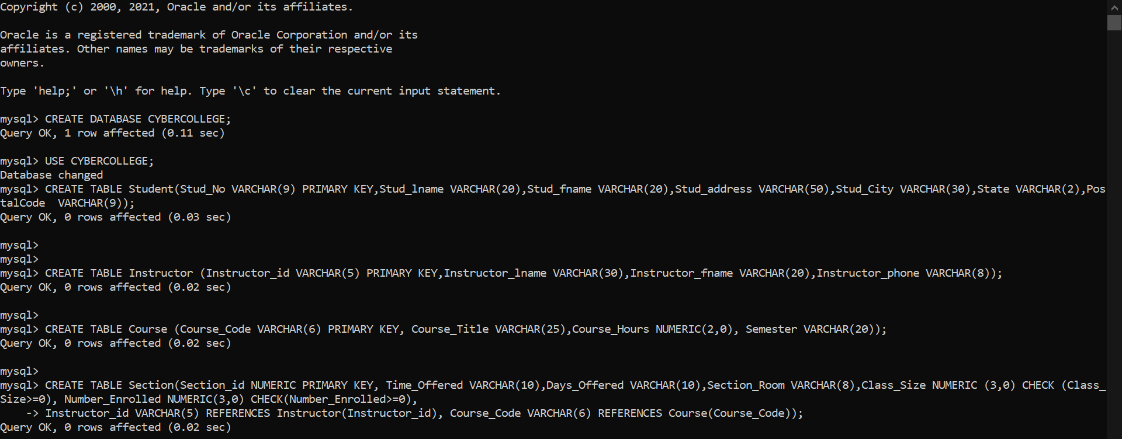

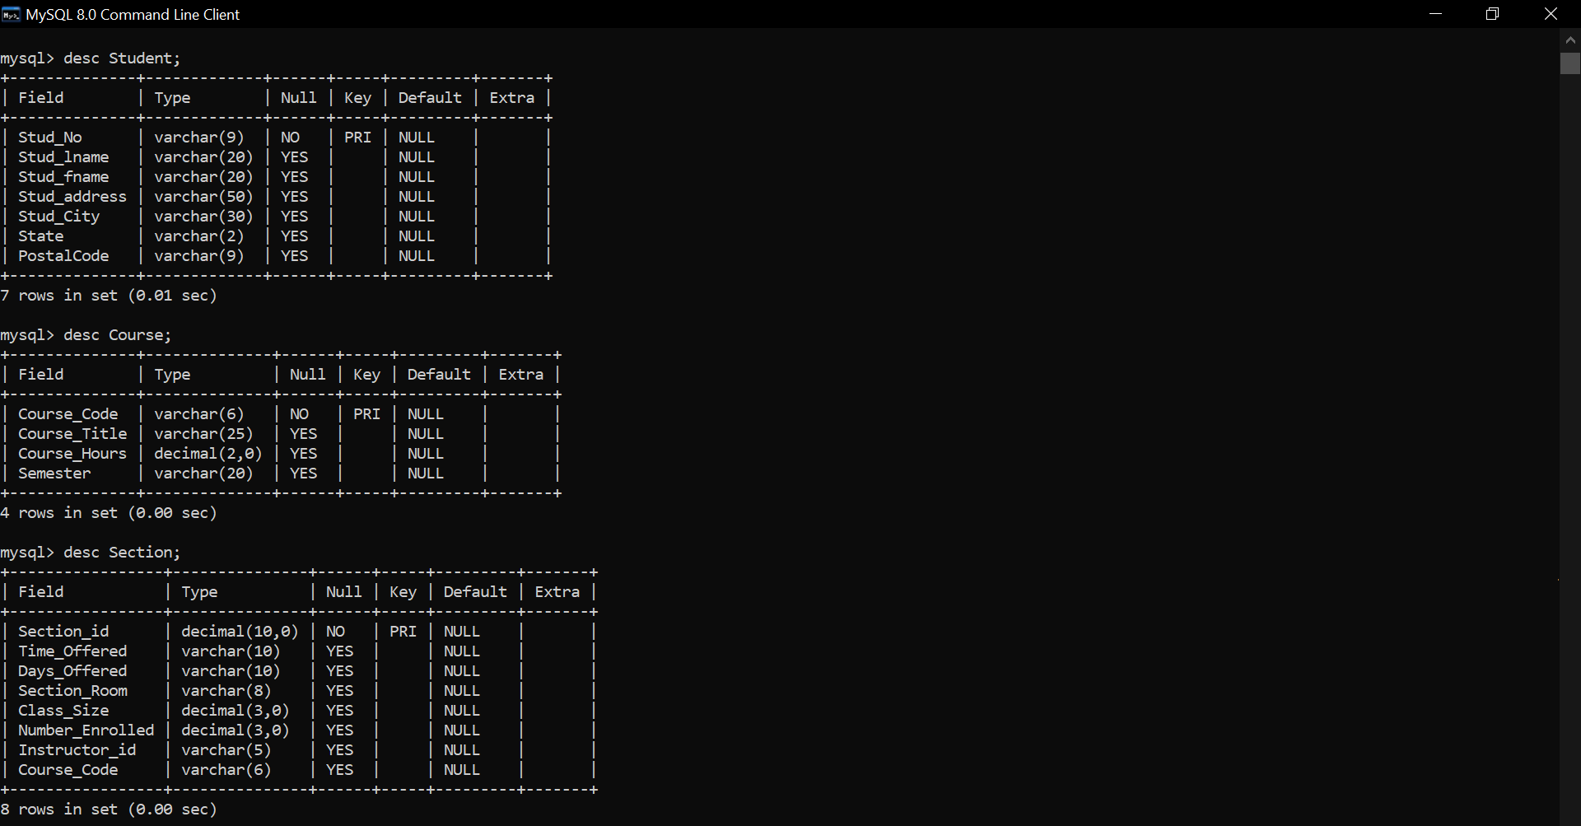

1. Add a field Country to the STUDENT table with the default value set to ‘India’.

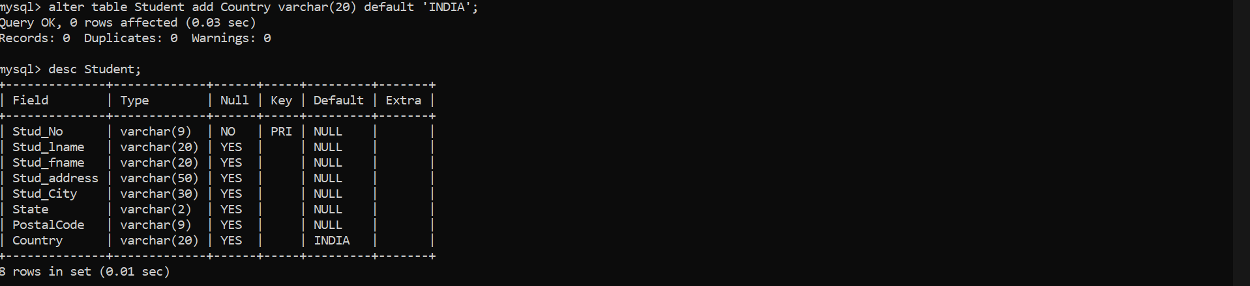

1. Add a constraint to the Grade field in the ENROLMENT table that accepts only the values 'A', 'B' , 'C' and ‘D’.

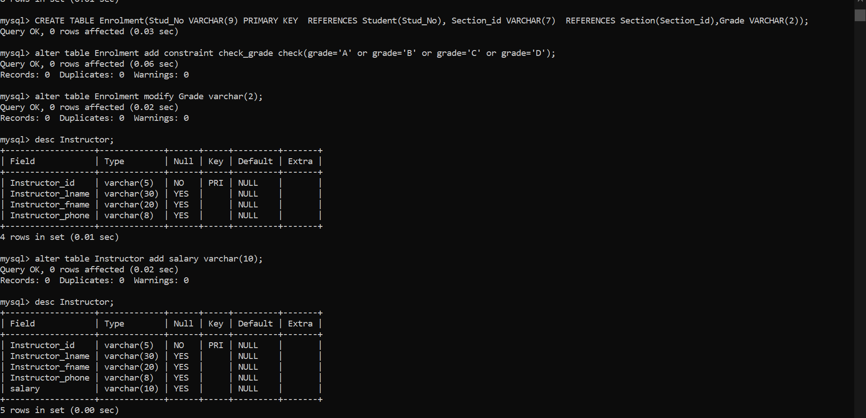

1. Modify the ENROLMENT table by changing the width of the field Grade to 2



1. Add a new column, salary to the INSTRUCTOR table and display its modified schema.



1. Drop the column Country from the STUDENT table.

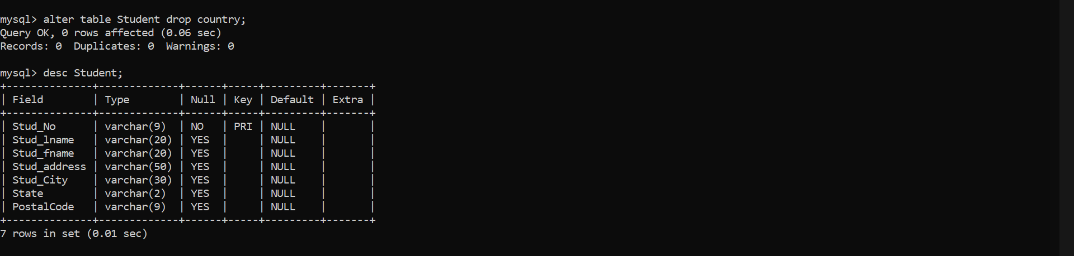

1. Create a view for instructors to display the courses taught by an instructor. Display the personal details but by hiding salary information.

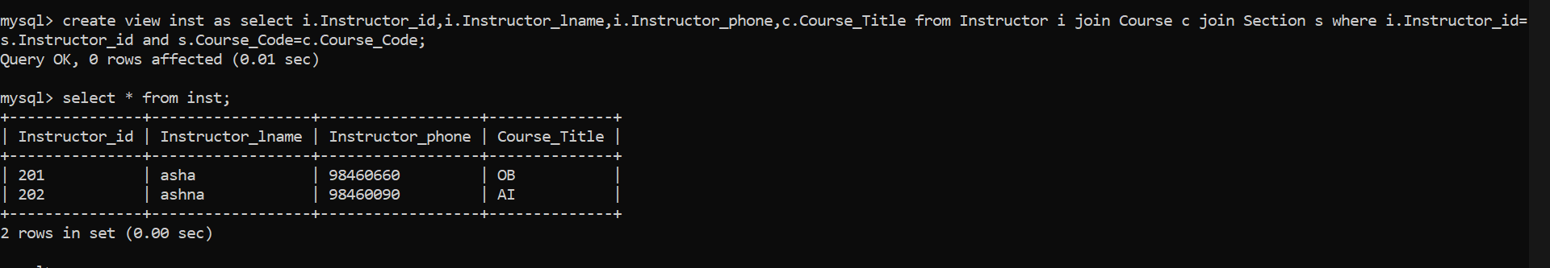

1. **DML Commands:**

1. Insert details of you and your 5 friends in STUDENT table and the details of 5 instructors with names (Asha, Ashna, Sandeep, Asifa, George) in INSTRUCTOR table.

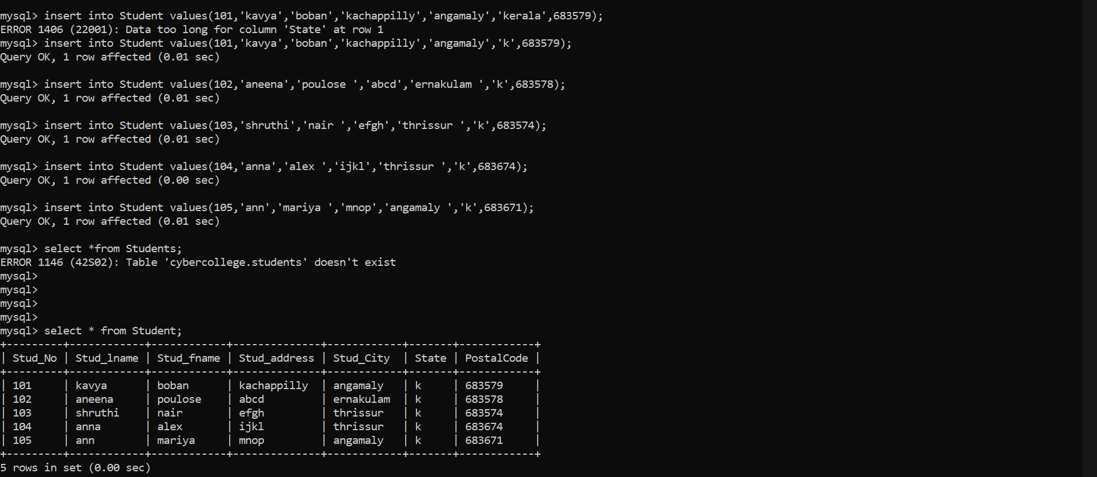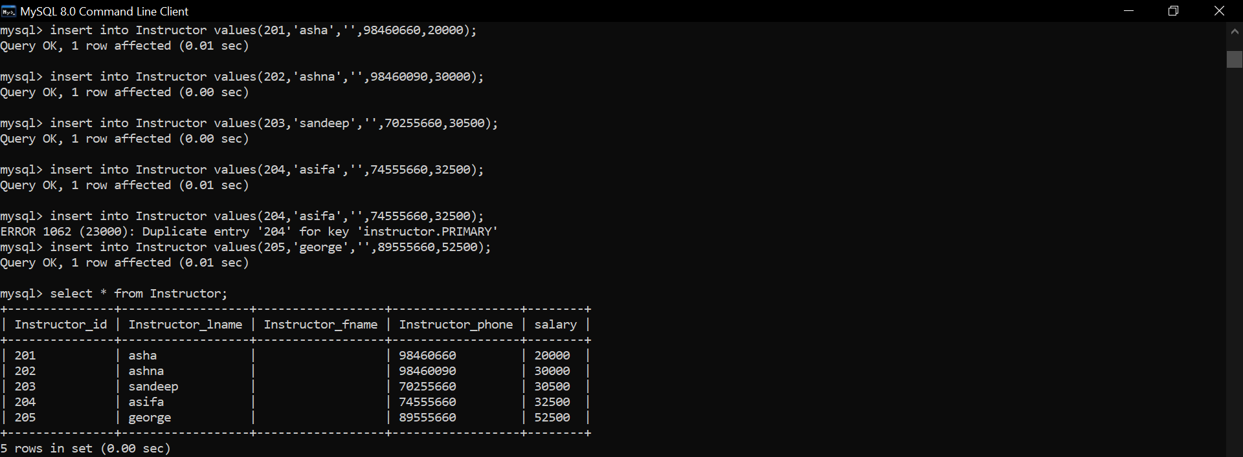

1. Add details of the first and second semester courses. Also add a new course for Data Mining with a course code of 20MCA260 worth with credit of 4 hours

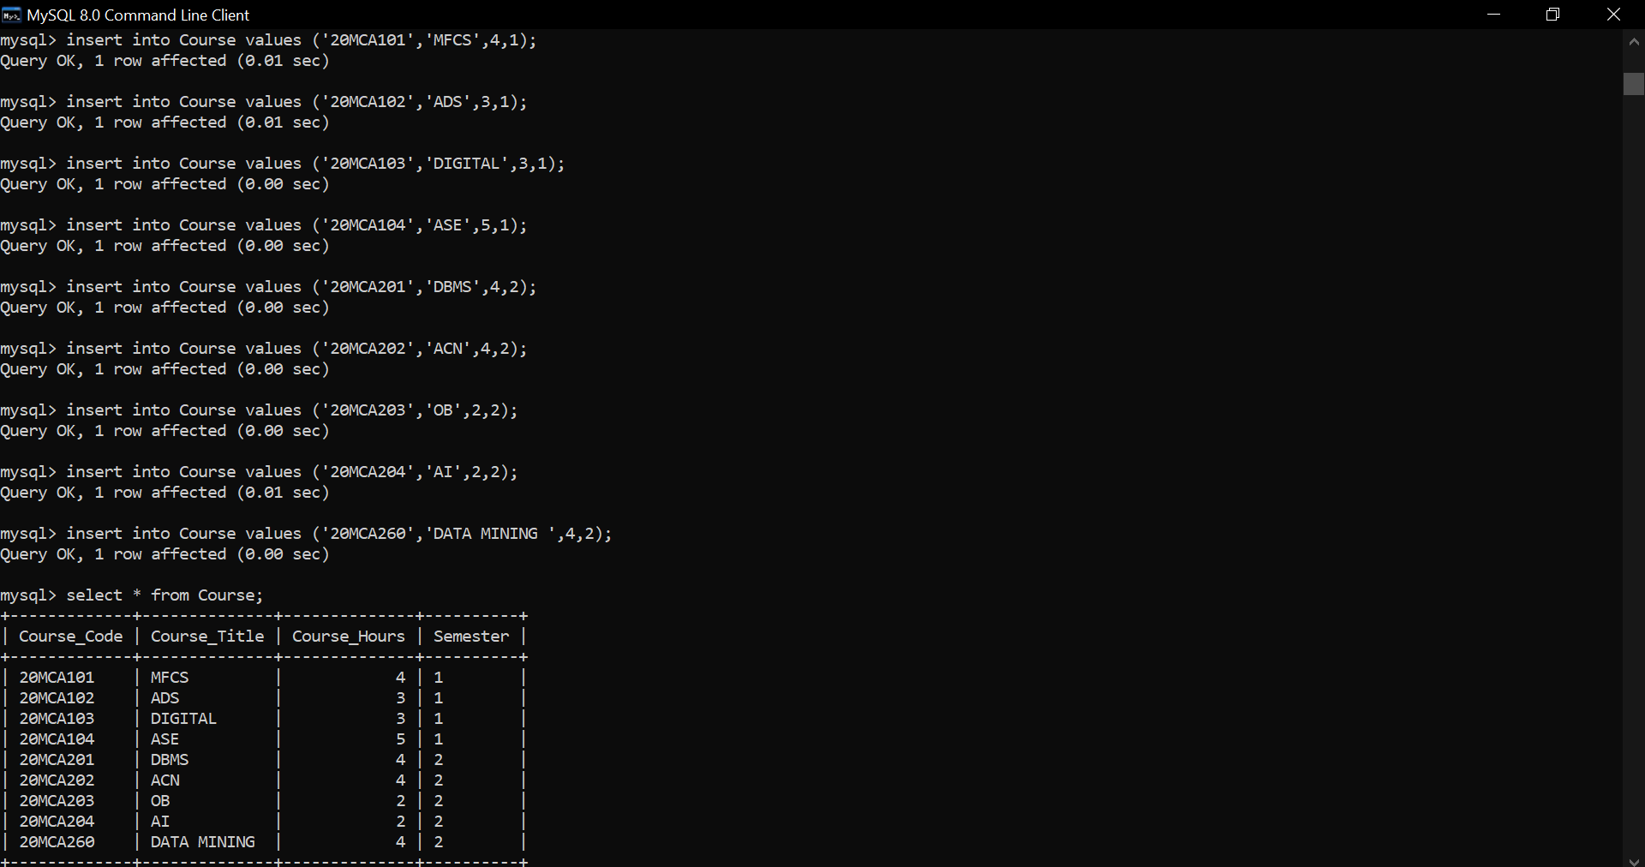

1. Add a new section for this new course with section ID as 301.The section should meet in 2-4 on MW in BLGNG102. The class size should be 35, and number enrolled should be 0.  The instructor should be 3, and the course is 20MCA260. Also add sections 302 and 303 for the courses AOS and OB and enrol 5 students each to these courses.

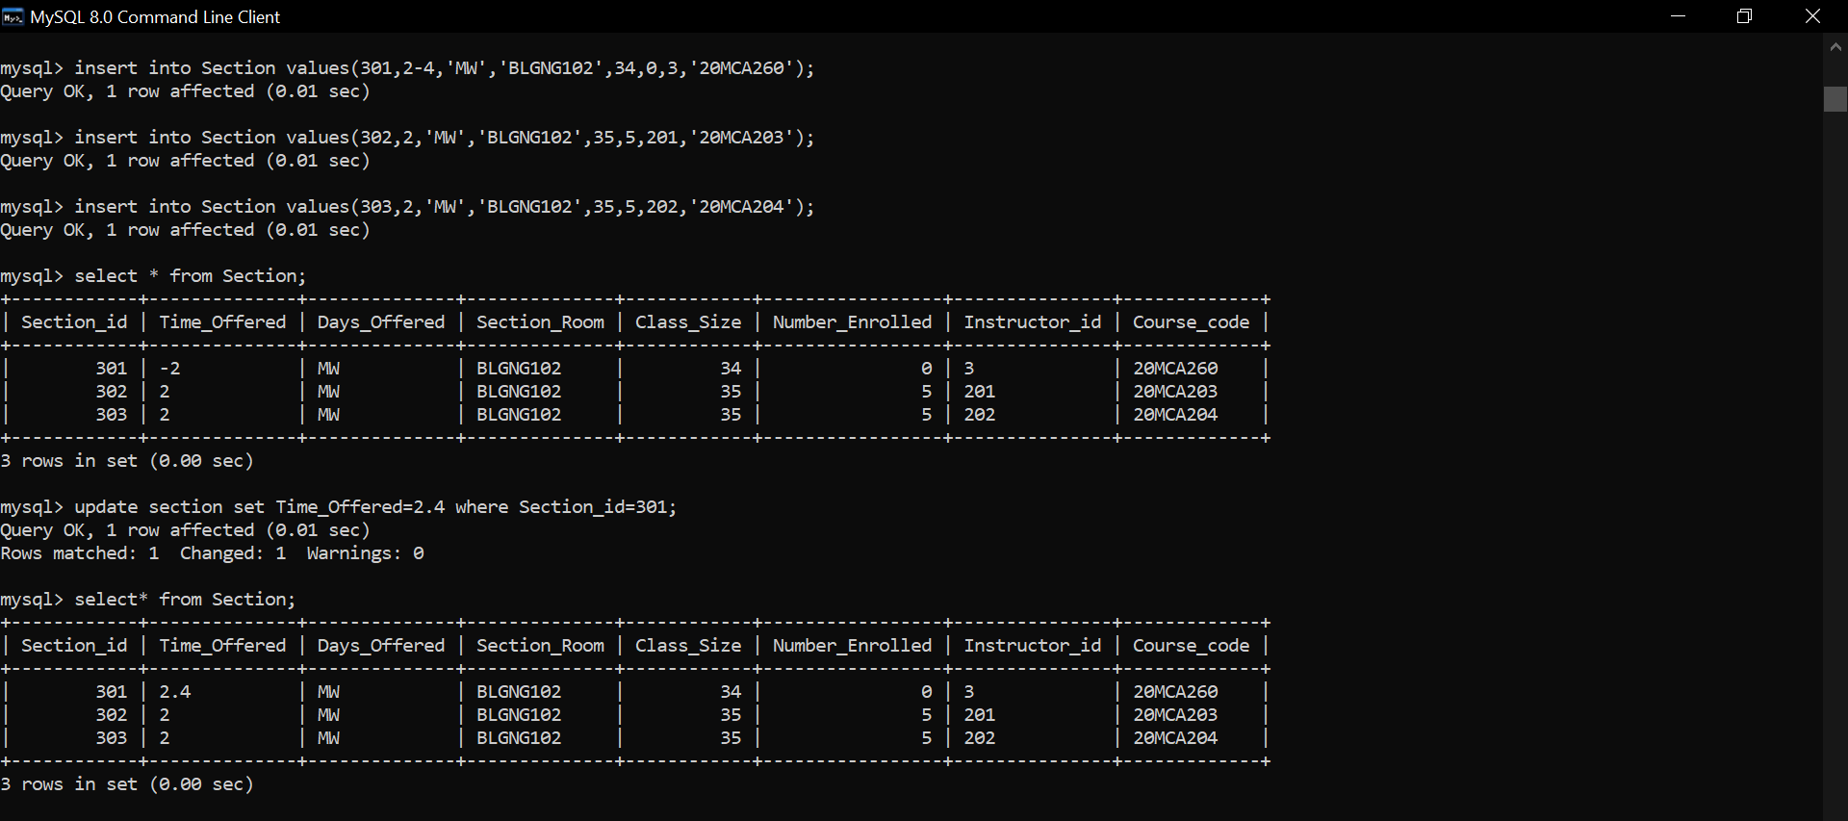

1. Register yourself along with your 3 friends for this new course by adding a row to the ENROLMENT table. The grade should be null.

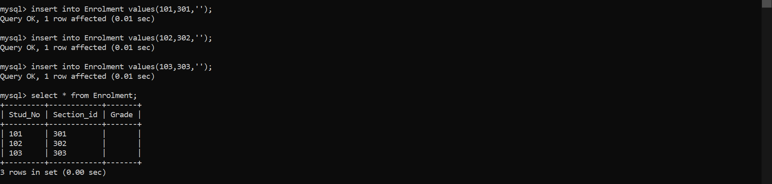

1. Update the 301 section, and increase the class sizes by 10%.

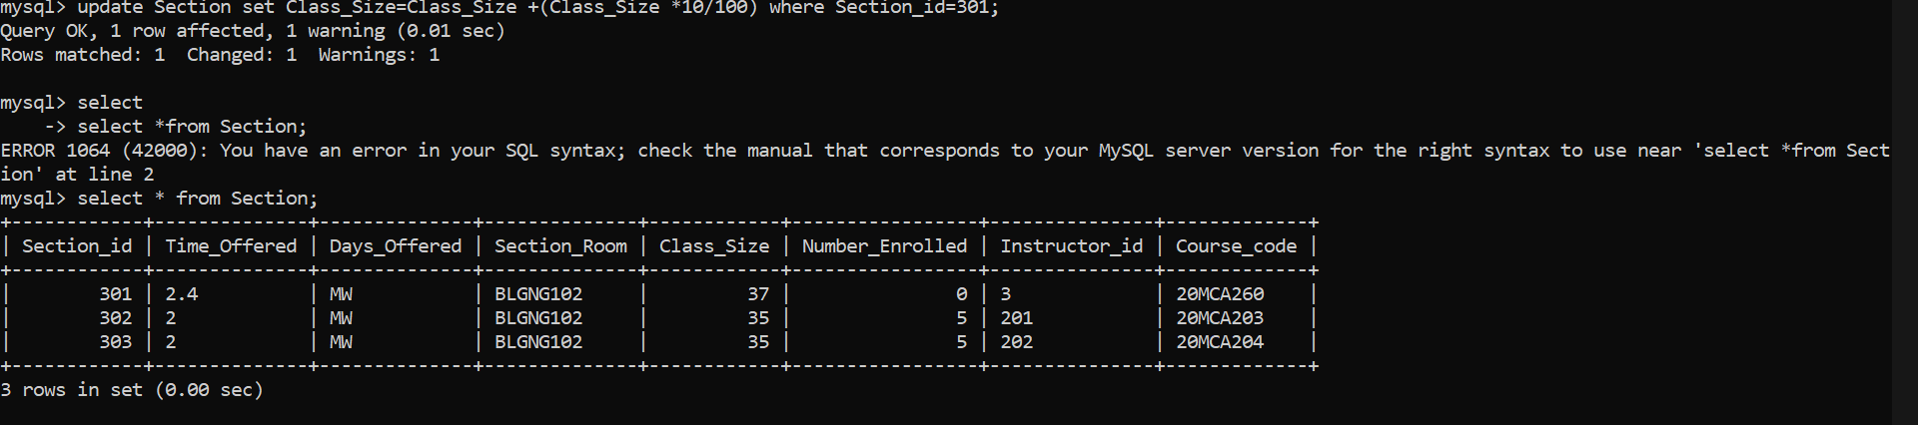

1. Give a 10% increment in salary for all instructors.

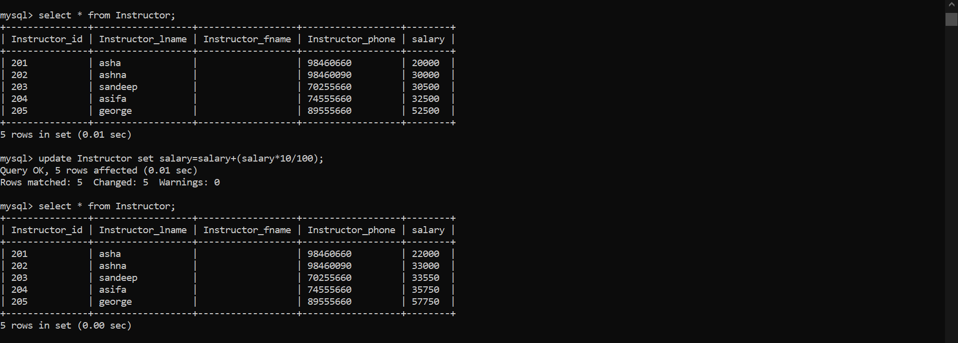

1. Delete Section 302and verify for the rows in ENROLMENT table for that section.

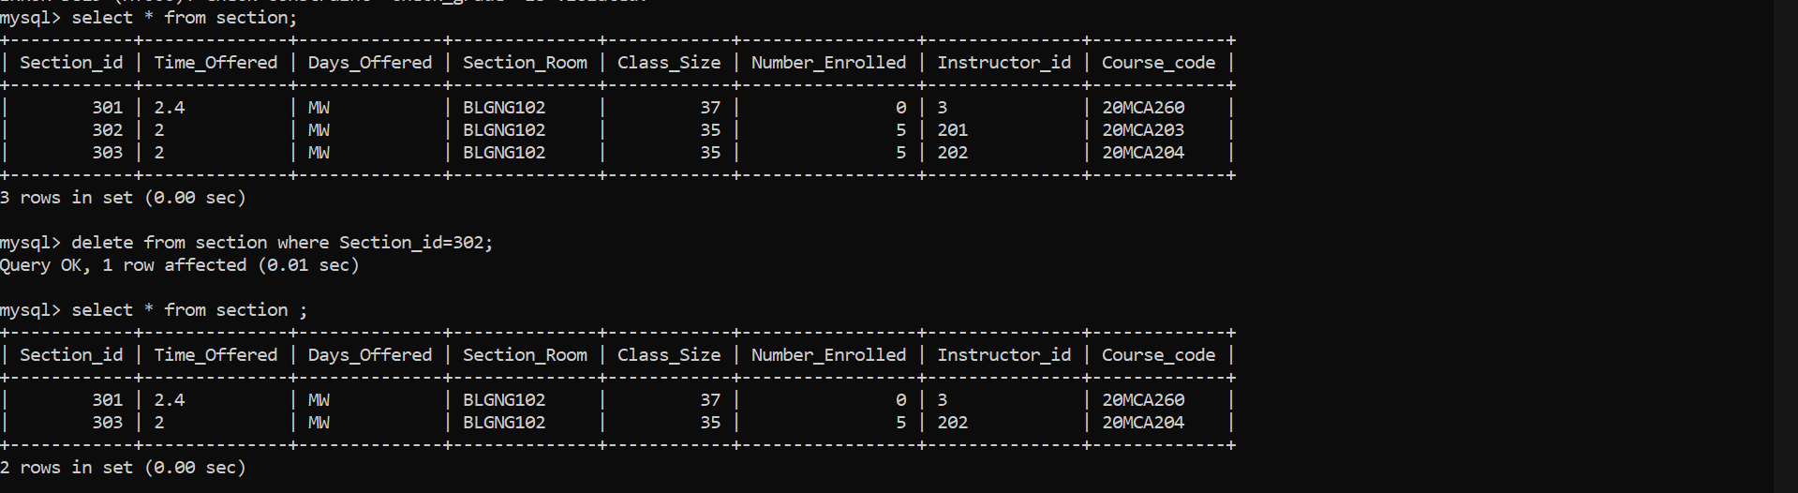

1. **TCL Commands:**
2. Undo the previous delete operation

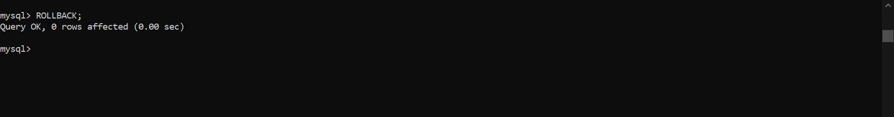

1. Save all the transactions to the database.

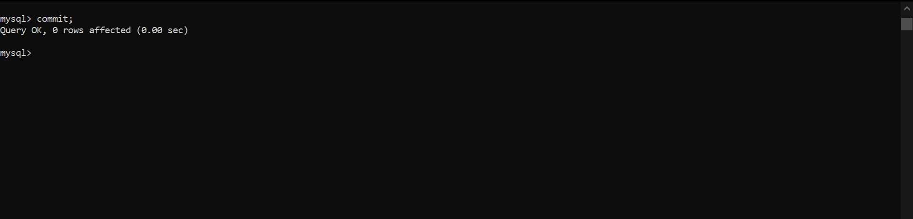

1. Grant the privilege to read and delete from the ENROLMENT table to the User U1.

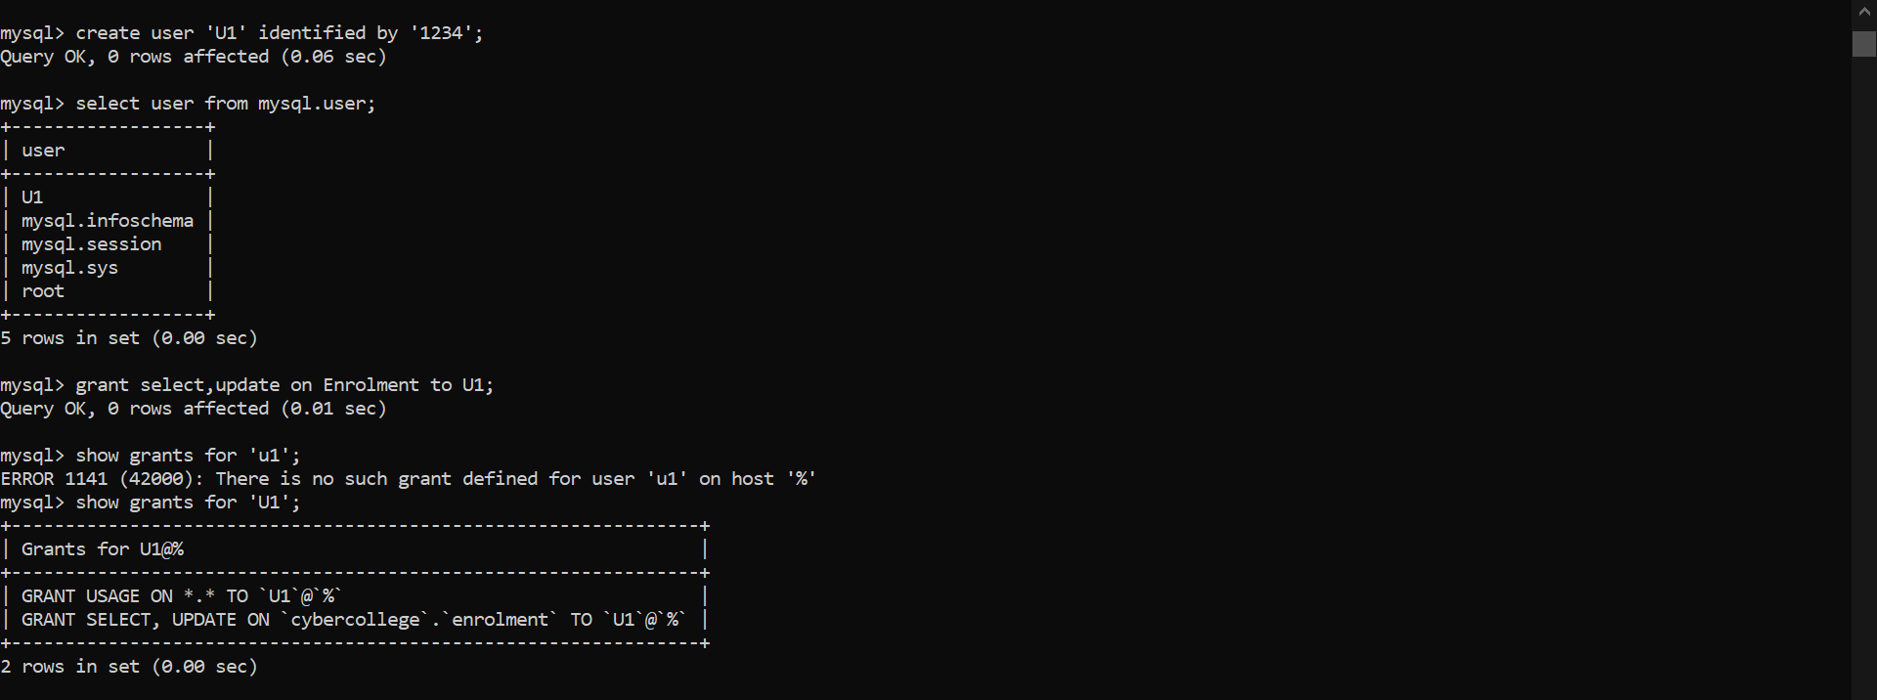

1. Revoke the delete privilege from U1

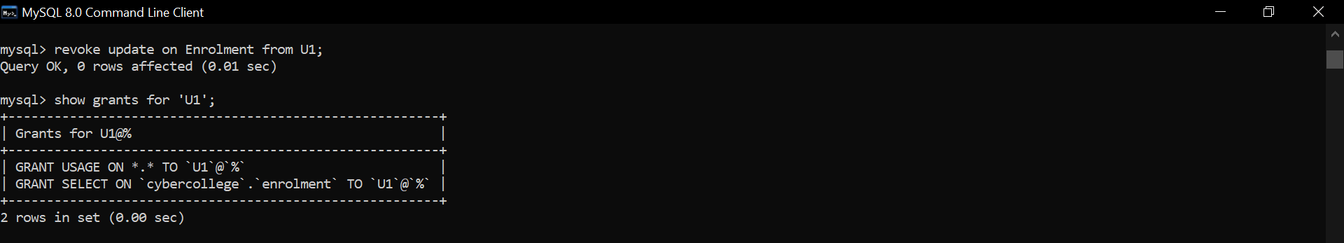

1. **Accessing database (SELECT, Filtering using WHERE, HAVING, GROUP BY, ORDER BY Clauses, Subquery):**

1. Display the full name and contact details of students living in Kochi.

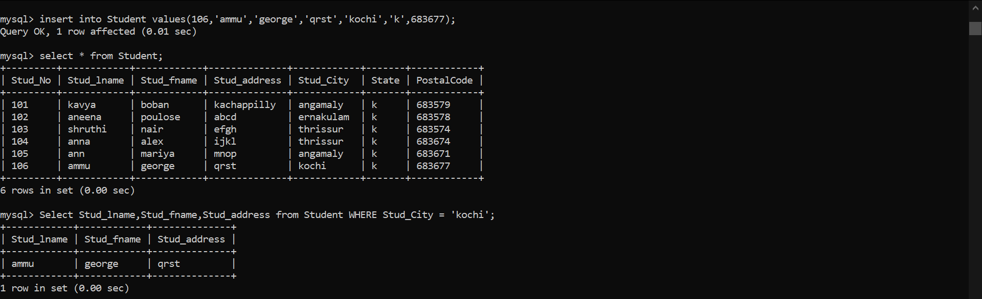

1. List the student details who has longest first name

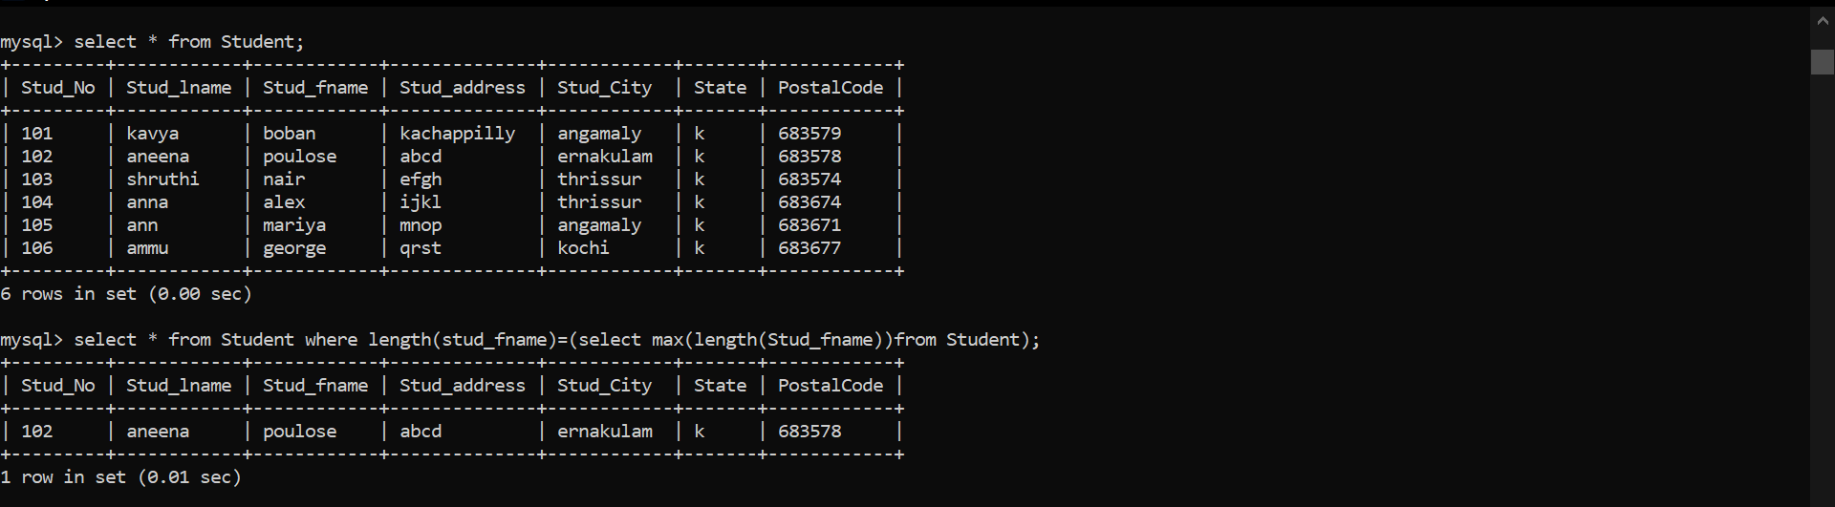

1. Display the name and phone number of the instructors who is handling the courses AOS and ADBMS.



1. List the codes, titles, and credit hours for courses worth 4 hours. Order the results in descending order of course code.

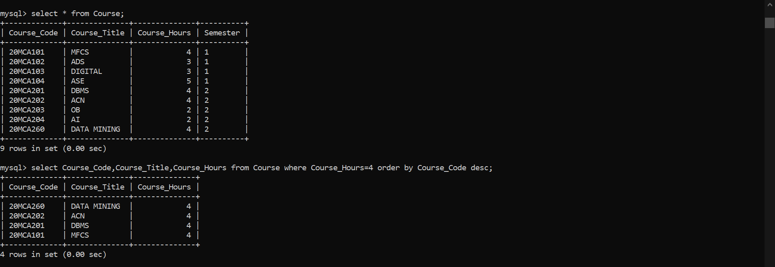

1. Display the names of the students in the descending order along with their phone number.

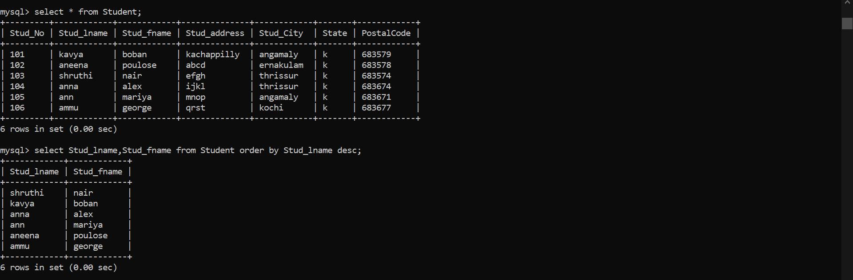

1. List the student’s name, course code and section id grouping the students by their grade.

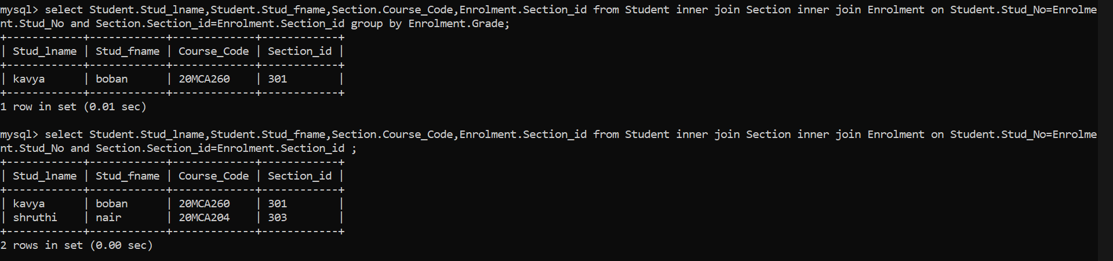

1. **Optimizing databases (Join, Aggregate & Set operations, Other operators like arithmetic, logical, special etc):**

1. Use an inner join between the STUDENT and ENROLMENT tables for showing the full name, Section id and Grade.

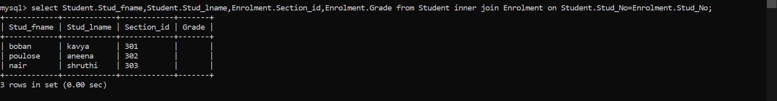

1. Use an outer join between the STUDENT and ENROLMENT tables for showing the full name, Section id and Grade. Include all the students regardless of whether they have a matching section.

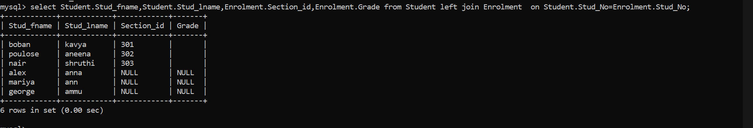

1. Give a 7% salary raise to instructors whose salary is less than the average.

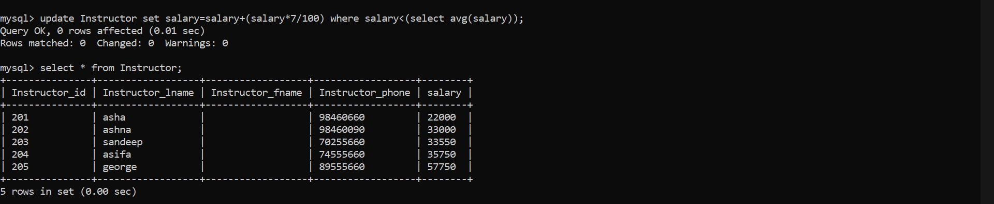

1. List full name and salary of instructors whose last name ends with ‘a’ and earns highest salary.

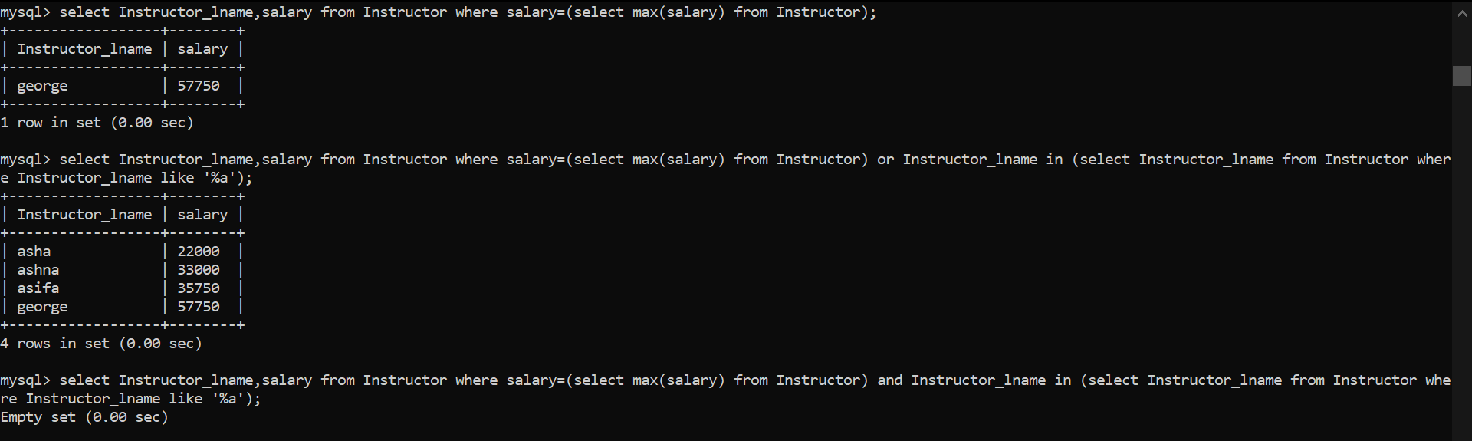

1. Display the details of instructor who draws lowest salary.

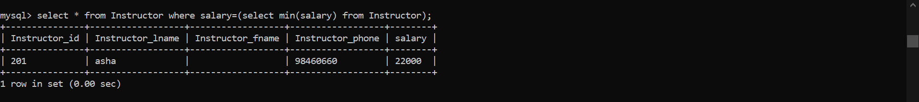

1. List the students details who lived in Kochi, Kerala or in Bangalore, Karnataka or both.

